JANTA VIDYA MANDIR GANPATRAI RASIWASIA COLLEGE, CHARKHI DADRI
Faculty Profile

Department ENGLISH

Name of Faculty |  | DR MANJEET MAAN |  |  | 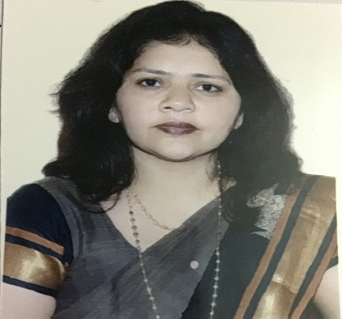
Department |  | ENGLISH
Designation |  | ASSOCIATE PROFESSOR
Experience |  | 17 YEARS
Contact No |  | 9416338511
Email Id |  | Manjeetsaggi2075@gmail.com
Date of Joining |  | 22/08/2007 ON REGULAR BASIS, 02/01.2023 IN THIS INSTITUTE
Educational Qualification
 | Name of Program |  | Year of  Passing | University
PG | M.A. |  | 2004 | MDU ROHTAK
Ph.D. |  |  | 2007 | MDU ROHTAK
Net
Other | M.PHIL |  | 2007 | CDLU, SIRSA
Research Supervision/Guidance
Research Publications |  | 12
Books Published |  | 4
Book Chapters |  | 5
Papers Presented in Conferences/ Seminar |  | International:12 National:15
Participated in Conferences/ Seminar |  | International:13 National:21
No. of Workshops/FDP/Training Programme Attended |  | 4
Major/Minor Research Projects |  | NA
Invited Lectures |  | 4
Awards/Honours |  | 7
Membership of Any  Professional/ Statutory Body |  | BOS, CBLU BHIWANI  MEMBER OS SHAKESPEARE ASSOCIATION (INDIA)  MEMBER OF ACCOUNTS COMMITTEE, CBLU BHIWANI
Any Other Achievement |  | - FORMER ASSOCIATE IN UGC-IUC CENTRE, INDIAN INSTITUTE OF ADVANCED STUDY, SHIMLA (2015-17)  - MEMBER OF ACADEMIC COUNCIL MDU, ROHTAK  (2017-19)  - GOLD MEDAL IN M. PHIL (ENGLISH)

